**NETLIST VIEWER**

**STATE DIAGRAM:**

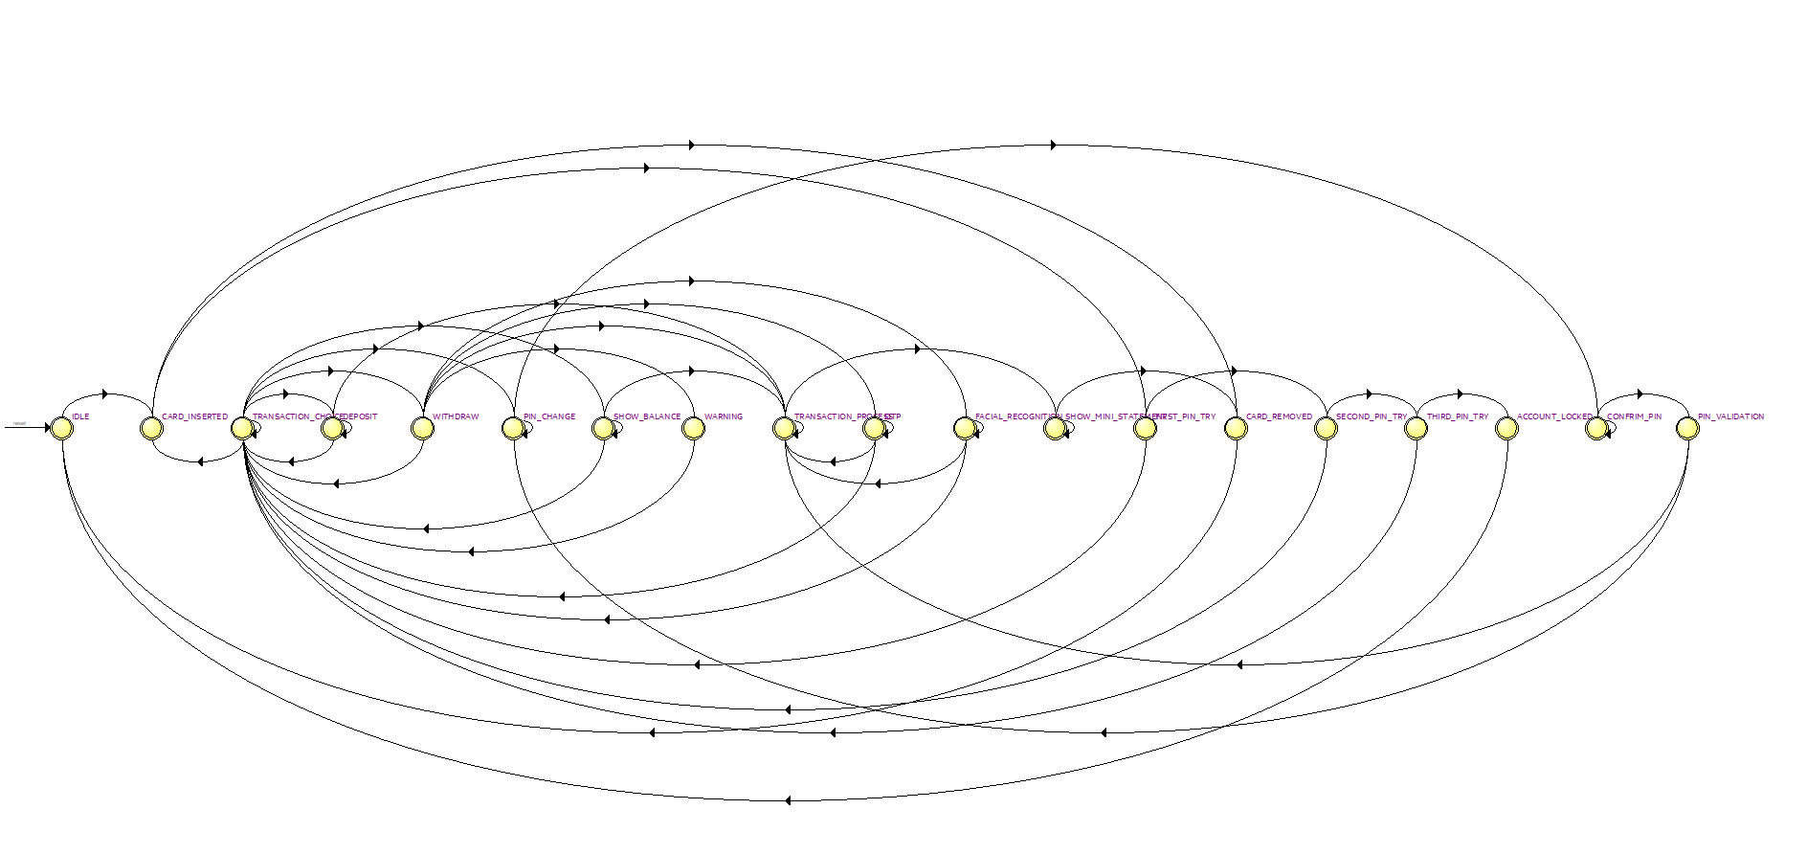

**RTL VIEWER:**

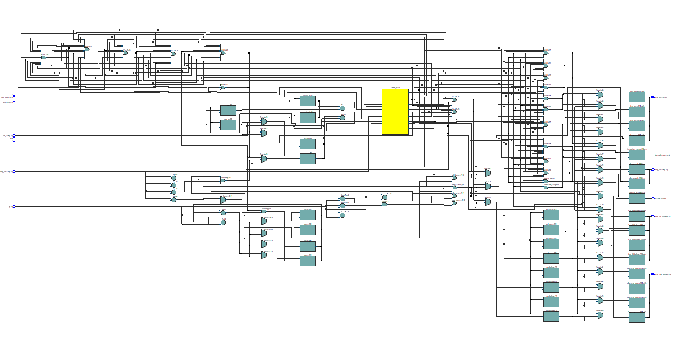

**TECHNOLOGY MAP VIEWER(POST MAPPING):**

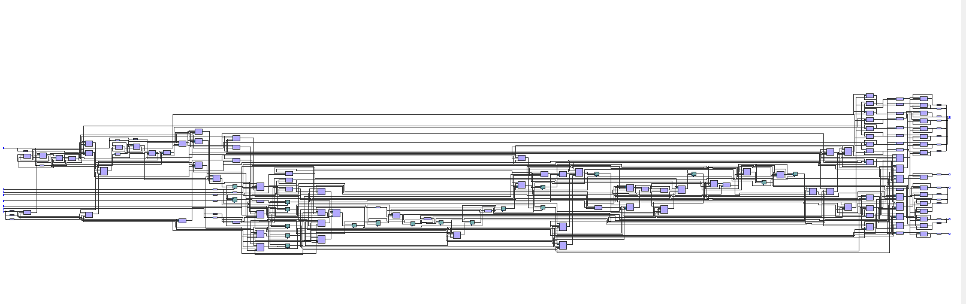

**TECHNOLOGY MAP VIEWER(POST FITTING):**

